* Google cloud infrastructure security design

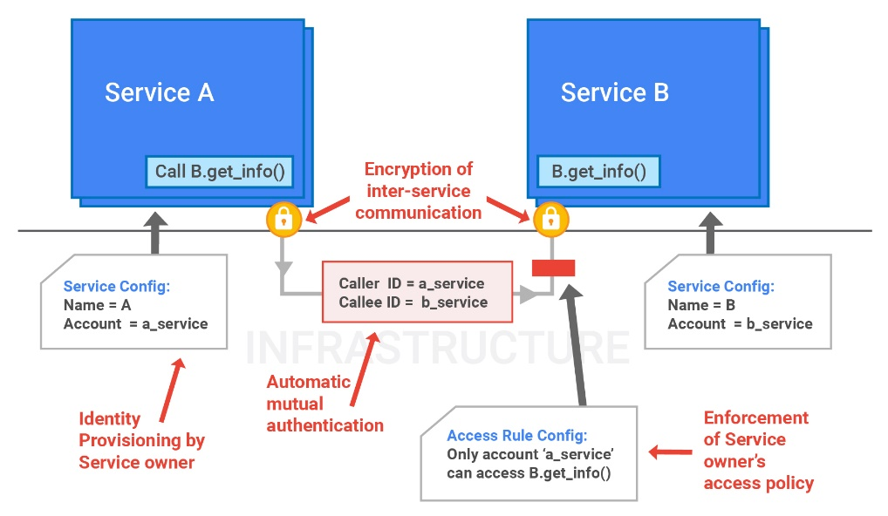

The infrastructure provides a central user identity service which issues these “end user permission tickets”. An end user login is verified by the central identity service which then issues a user credential, such as a cookie or OAuth token, to the user’s client device. Every subsequent request from the client device into Google needs to present that user credential.

When a service receives an end user credential, it passes the credential to the central identity service for verification. If the end user credential verifies correctly, the central identity service returns a short-lived “end user permission ticket” that can be used for RPCs related to the request. In our example, that service which gets the “end user permission ticket” would be the Gmail service, which would pass it to the Contacts service. From that point on, for any cascading calls, the “end user permission ticket” can be handed down by the calling service to the callee as a part of the RPC call.

<https://cloud.google.com/security/infrastructure/design/>

Google cloud platform (GCP) Networking Fundamentals

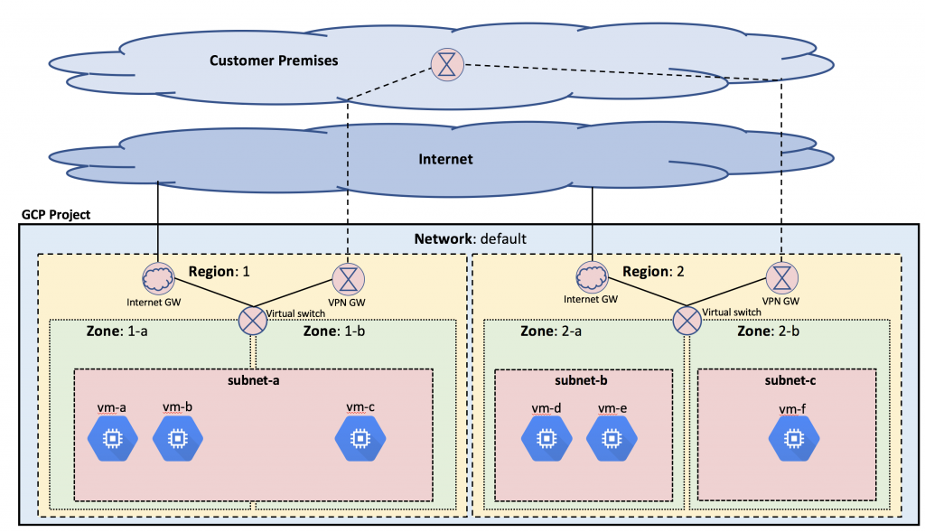

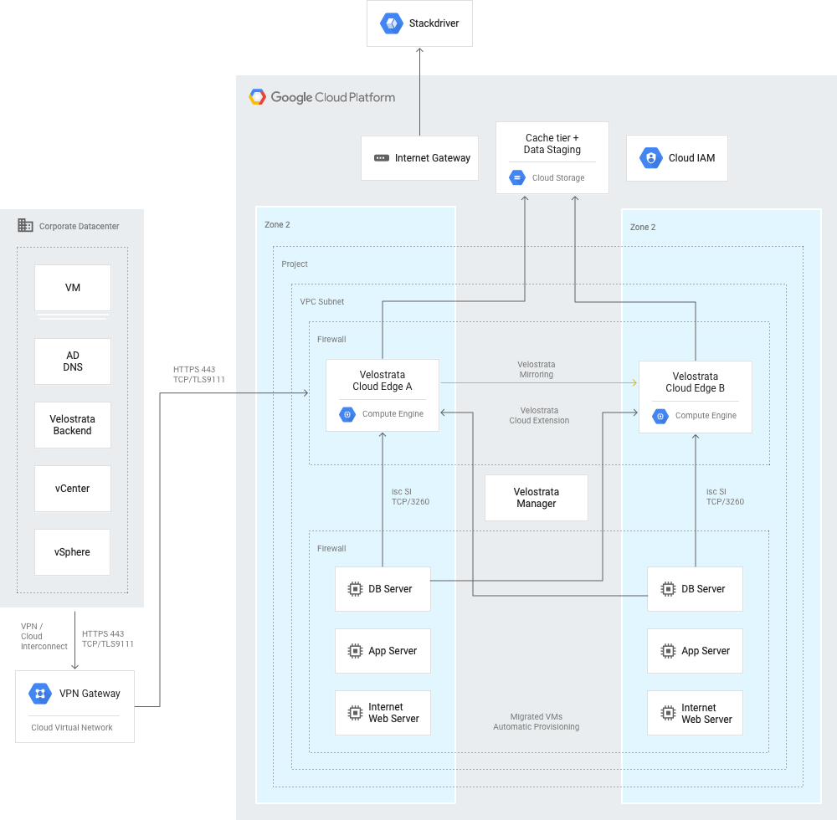

Comparison of data center and Cloud Platform
    VPC networking architectures

In a traditional data center, you manage a complex network setup composed of racks of servers, storage devices, multiple layers of switches, routers, load balancers, firewall devices, and more. In addition to these hardware components, you must set up, maintain, and monitor the network's underlying software, as well as detailed device configurations for your environment. And the managerial overhead doesn't end there: you also have to worry about the security and availability of your network, and you must plan out the upgrades and expansions of your network—a lengthy and time-consuming process.

In contrast, Cloud Platform’s VPC networking infrastructure is built around a software-defined networking (SDN) model. This model removes much of the aforementioned maintenance and managerial overhead so that you can more rapidly customize and scale your services to help meet the needs of your growing customer base.

A **VPN**, or **virtual private network**, is a secure tunnel between your device and the internet.

Daniel E. Eisenbud, Cheng Yi, Carlo Contavalli, Cody Smith,

Roman Kononov, Eric Mann-Hielscher, Ardas Cilingiroglu, Bin Cheyney,

Wentao Shang†* and Jinnah Dylan Hosein‡*

|  |  |
| --- | --- |
| Pluk Sreyphanne | The latest technology of data operation and network |
| Nom Vannkinh |  |
| Pork Chanchen | Logical infrastructure of google cloud  Physical infrastructure of google cloud |
| Sea Hutmonineat | Technology of data operation accurate of Google cloud |
| Ly Kimleang | Marketing design and marketing strategy of Google cloud |